**Onboarding Guidelines for New Joinees**

**=================================**

1. Tech Bootcamp GitHub Repository 1

2. Install Required Software 1

3. Tech Bootcamp 1

4. SharePoint Folder 1

5. Consolidated Scores and Reports 2

6. Interview Questions 2

7. Data Structures and Algorithms 2

8. Leet Code 2

**Hi. Welcome to Tech Bootcamp.**

**Pls. Go through the following carefully so you can get up to speed quickly and easily.**

# Tech Bootcamp GitHub Repository

Visit [StevenJoseph19/GS-Training: Repository for Training Materials for Advanced](https://github.com/StevenJoseph19/GS-Training)  Java and DSA of GSA Training . This repo contains the Training materials and related artifacts. Ensure Git is installed on your computer. Clone the repo to a folder on your local. Any updates to the repo can be pulled later using ‘**git pull**’.

If you face a problem cloning the repository due to long filenames, look at ‘**Git Long**  **Paths Enable.txt**’ in the ‘**Git**’ folder.

# Install Required Software

Check ‘**Required Software and Setup.xlsx**’ in the ‘**Setup and Installation**’ folder. Raise the required tickets to install the software. In particular, raise a ticket to open the firewall for Java and IntelliJ. This is required for Kafka training.

# Tech Bootcamp Recordings

Go through the recordings you have missed and do the Hands-on Exercises. The link for the recordings is in the ‘**Links**’ folder in an excel file - **Tech-Bootcamp-Links.xlsx.** There is a **‘Recordings’** sheet **i**n the **Consolidated Scores and Reports.xlsx.** It lists date wise the topics covered. Use it to find the recording in the sharepoint folder. Visit the other links to familiarize yourself with the other artifacts related to the training.

# SharePoint Folder

A SharePoint folder will be created for you personally. Only you and the trainers have access to it. You are required to upload your Hands-on Assignments and the Hands-on Demos done during the training sessions. The link to your SharePoint folder will be shared over email.

**Follow the below structure for your Hands-on Assignments:**

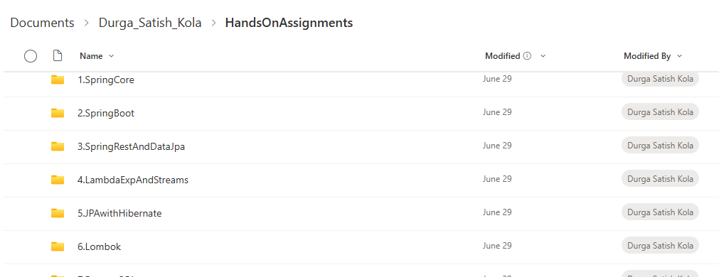

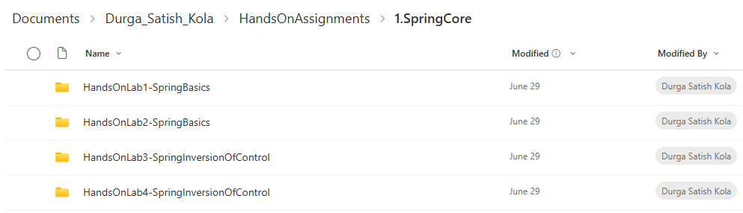

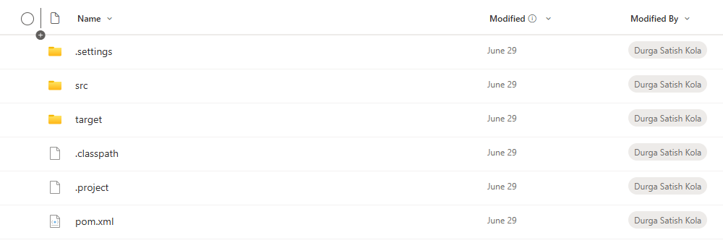

**Follow the below structure for your Hands-on Demos:**

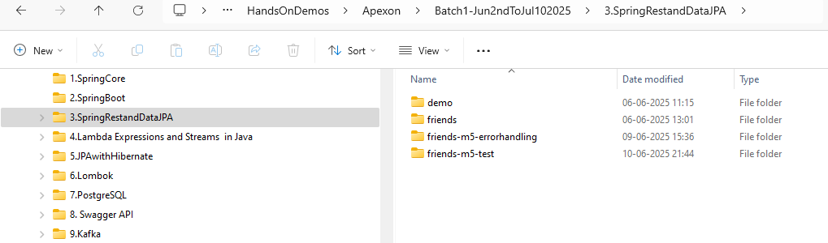

This should be the same structure as done in the training session.

# Consolidated Scores and Reports

There is a ‘**Consolidated Scores and Reports.xlsx’** link in the ‘**Tech-Bootcamp-Links.xlsx’** document. Besides attendance records, it also contains the status of assigned tasks.

# Interview Questions

There is an ‘**Interview Questions**’ folder with sub folders for different technologies. These are curated questions and answers from Golman Sachs interviews. Study them carefully as question patterns are repeated.

# Data Structures and Algorithms

The DSA folder contains recurring questions asked in GS coding interviews. The face-to-face kind. You are expected to solve every one of them. This is crucial to your interview preparation.

# Leet Code

This folder contains assignments which you will be allocated when time permits. You need to send your submissions to [Stephen.Samuels@apexon.com](mailto:Stephen.Samuels@apexon.com) and [Michael.Samuel@apexon.com](mailto:Michael.Samuel@apexon.com) in the format given in ‘**Sample Leet Code**  **Submissions.docx**’.

********************************************************************************************************************************